LAB#07

Implementation of CPU Scheduling Algorithm (i)Round Robin (ii)Priority based

- ROUND ROBIN ALGORITHM:
A round-robin scheduling algorithm is used to schedule the process fairly for each job a time slot or quantum and the interrupting the job if it is not completed by then the job come after the other job which is arrived in the quantum time that makes these scheduling fairly.

Note:
  - Round-robin is cyclic in nature, so starvation doesn’t occur
  - Round-robin is a variant of first come, first served scheduling
  - No priority, special importance is given to any process or task
  - RR scheduling is also known as Time slicing scheduling

Advantages:
  - Each process is served by CPU for a fixed time, so priority is the same for each one
  - Starvation does not occur because of its cyclic nature.

Disadvantages:
  - Throughput depends on quantum time.
  - If the time quantum is too large RR degrades to FCFS.
  - If we want to give some process priority, we cannot.
Process | Arrival Time | Burst Time | Completion time | Turn Around Time | Waiting time
P1 | 0 | 5 | 12 | 12 | 7
P2 | 1 | 4 | 11 | 10 | 6
P3 | 2 | 2 | 6 | 4 | 2
P4 | 3 | 1 | 9 | 6 | 5
Quantum time is 2 this means each process is only executing for 2 units of time at a time.

How to compute these process requests:-
- Take the process which occurs first and start executing the process(for quantum time only).
- Check if any other process request has arrived. If a process request arrives during the quantum time in which another process is executing, then add the new process to the Ready queue
- After the quantum time has passed, check for any processes in the Ready queue. If the ready queue is empty then continue the current process. If the queue not empty and the current process is not complete, then add the current process to the end of the ready queue.
- Take the first process from the Ready queue and start executing it (same rules)
- Repeat all steps above from 2-4
- If the process is complete and the ready queue is empty then the task is complete
After all these we get the three times which are:
- Completion Time: the time taken for a process to complete.
- Turn Around Time: total time the process exists in the system. (completion time – arrival time).
- Waiting Time: total time waiting for their complete execution. (turn around time – burst time ).

How to implement in a programming language
1. Declare arrival[], burst[], wait[], turn[] arrays
them. Also declare
variable and initialize it to zero. To sustain array create
and initialize
a timer
the original burst
another
array (temp_burst[]) and copy all the values of burst array in it.
2. To keep a check we create another array of bool type which keeps the record of whether a process is completed or not. we also need to maintain a queue array
which contains
indices array
the
is
process
(initially
the
filled
with
0).
3. Now we increment the timer variable until the first process arrives
and when it
process index
does,
to
we
the
add
queue
the
array
4. Now we execute the first process until the time quanta and during
that time quanta, we check whether any other process has arrived or not and if it has then we

add
(by
the
calling
index
the
in
fxn.
the
queue
queueUpdation()).
5. Now, after doing the above steps if a process has finished, we store
its
execute currently
the end when
exit
time
and
the next process in the queue array. Else, we move the
executed
of the queue (by calling
process
at
another fxn. queueMaintainence())
the
time
slice
expires.
6. The above steps are then repeated until all the processes have been
completely
scenario not
executed.
If
arises where there are some processes left
arrived
yet,
then
a
but they have
we
shall wait and the CPU will remain idle during this interval.

PROGRAMMING CODE:

// C# program to implement Round Robin
// Scheduling with different arrival time
using System;

class GFG {
public static void roundRobin(String[] p, int[] a,
int[] b, int n)
{
// result of average times
int res = 0;
int resc = 0;

// for sequence storage String seq = "";

// copy the burst array and arrival array
// for not effecting the actual array int[] res_b = new int[b.Length]; int[] res_a = new int[a.Length];

for (int i = 0; i < res_b.Length; i++) { res_b[i] = b[i];
res_a[i] = a[i];
}

// critical time of system
int t = 0;

// for store the waiting time
int[] w = new int[p.Length];

// for store the Completion time
int[] comp = new int[p.Length];

while (true) {
Boolean flag = true;
for (int i = 0; i < p.Length; i++) {

// these condition for if
// arrival is not on zero

// check that if there come before qtime
if (res_a[i] <= t) {
if (res_a[i] <= n) {
if (res_b[i] > 0) { flag = false;
if (res_b[i] > n) {

// make decrease the b time t = t + n;
res_b[i] = res_b[i] - n; res_a[i] = res_a[i] + n; seq += "->" + p[i];
}

else {

// for last time t = t + res_b[i];

// store comp time comp[i] = t - a[i];

// store wait time
w[i] = t - b[i] - a[i]; res_b[i] = 0;

// add sequence
seq += "->" + p[i];
}
}
}
else if (res_a[i] > n) {

// is any have less arrival time
// the coming process then execute
// them
for (int j = 0; j < p.Length; j++) {

// compare
if (res_a[j] < res_a[i]) {
if (res_b[j] > 0) { flag = false;
if (res_b[j] > n) { t = t + n; res_b[j]
= res_b[j] - n; res_a[j]
= res_a[j] + n; seq += "->" + p[j];
}

else {
t = t + res_b[j]; comp[j] = t - a[j];
w[j] = t - b[j]
- a[j]; res_b[j] = 0;
seq += "->" + p[j];
}
}
}
}

// now the previous process
// according to ith is process
if (res_b[i] > 0) { flag = false;

// Check for greaters
if (res_b[i] > n) { t = t + n;
res_b[i] = res_b[i] - n; res_a[i] = res_a[i] + n; seq += "->" + p[i];
}

else {
t = t + res_b[i]; comp[i] = t - a[i];

w[i] = t - b[i] - a[i]; res_b[i] = 0;
seq += "->" + p[i];
}
}
}
}

// if no process is come on the critical
else if (res_a[i] > t) { t++;
i--;
}
}

// for exit the while loop
if (flag) {

break;
}
}

Console.WriteLine("name ctime wtime");
for (int i = 0; i < p.Length; i++) { Console.WriteLine(" " + p[i] + "\t" + comp[i]
+ "\t" + w[i]);

res = res + w[i];
resc = resc + comp[i];
}

Console.WriteLine("Average waiting time is "
+ (float)res / p.Length); Console.WriteLine("Average compilation time is "
+ (float)resc / p.Length); Console.WriteLine("Sequence is like that " + seq);
}

// Driver Code
public static void Main(String[] args)
{
// name of the process
String[] name = { "p1", "p2", "p3", "p4" };

// arrival for every process
int[] arrivaltime = { 0, 1, 2, 3 };

// burst time for every process
int[] bursttime = { 10, 4, 5, 3 };

// quantum time of each process
int q = 3;

// cal the function for output roundRobin(name, arrivaltime, bursttime, q);
}
}

OUTPUT:
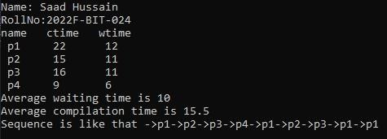

(B) A slightly optimized version of the above-implemented code could be done by using Queue data structure as follows:

using System;
using System.Collections.Generic;
using System.Linq;

class GFG
{
// At every time quantum or when a process has been
// executed before the time quantum, check for any new
// arrivals and push them into the queue

public static void
checkForNewArrivals(Process[] processes, int n,

int currentTime, Queue<int> readyQueue)
{
for (int i = 0; i < n; i++)
{
Process p = processes[i];
// checking if any processes has arrived
// if so, push them in the ready Queue.
if (p.arrivalTime <= currentTime && !p.inQueue && !p.isComplete)
{
processes[i].inQueue = true; readyQueue.Enqueue(i);
}
}
}

// Context switching takes place at every time quantum
// At every iteration, the burst time of the processes
// in the queue are handled using this method

public static void
updateQueue(Process[] processes, int n, int quantum, Queue<int> readyQueue, int currentTime, int programsExecuted)
{
int i = readyQueue.Dequeue();

// if the process is going to be finished executing,
// ie, when it's remaining burst time is less than
// time quantum mark it completed and increment the
// current time and calculate its waiting time and
// turnaround time
if (processes[i].burstTimeRemaining <= quantum)
{
processes[i].isComplete = true;
currentTime += processes[i].burstTimeRemaining; processes[i].completionTime = currentTime; processes[i].waitingTime
= processes[i].completionTime
- processes[i].arrivalTime
- processes[i].burstTime; processes[i].turnaroundTime
= processes[i].waitingTime
+ processes[i].burstTime;

if (processes[i].waitingTime < 0) processes[i].waitingTime = 0;

processes[i].burstTimeRemaining = 0;

// if all the processes are not yet inserted in
// the queue, then check for new arrivals
if (programsExecuted != n)
{

}
}

else
{
checkForNewArrivals(
processes, n, currentTime, readyQueue);

// the process is not done yet. But it's going
// to be pre-empted since one quantum is used
// but first subtract the time the process used
// so far
processes[i].burstTimeRemaining -= quantum; currentTime += quantum;

// if all the processes are not yet inserted in
// the queue, then check for new arrivals
if (programsExecuted != n)
{
checkForNewArrivals(
processes, n, currentTime, readyQueue);
}
// insert the incomplete process back into the
// queue readyQueue.Enqueue(i);
}
}

// Just a function that outputs the result in terms of
// their PID.
public static void output(Process[] processes, int n)
{
double avgWaitingTime = 0;
double avgTurntaroundTime = 0;
// sort the processes array by processes.PID processes = processes.OrderBy(p => p.pid).ToArray();

for (int i = 0; i < n; i++)

{
Console.WriteLine("Process " + processes[i].pid
+ ": Waiting Time: "
+ processes[i].waitingTime
+ " Turnaround Time: "
+ processes[i].turnaroundTime); avgWaitingTime += processes[i].waitingTime; avgTurntaroundTime
+= processes[i].turnaroundTime;
}
Console.WriteLine("Average Waiting Time: "
+ avgWaitingTime / n); Console.WriteLine("Average Turnaround Time: "
+ avgTurntaroundTime / n);
}

/*
- This function assumes that the processes are already
- sorted according to their arrival time
*/
public static void roundRobin(Process[] processes,
int n, int quantum)
{
Queue<int> readyQueue
= new Queue<int>();
readyQueue.Enqueue(0); // initially, pushing the first
// process which arrived first processes[0].inQueue = true;

int currentTime
= 0; // holds the current time after each
// process has been executed
int programsExecuted
= 0; // holds the number of programs executed so
// far

while (readyQueue.Count() > 0)
{
updateQueue(processes, n, quantum, readyQueue, currentTime, programsExecuted);
}
}

public class Process
{

public int pid;
public int arrivalTime;
public int burstTime;
public int burstTimeRemaining; // the amount of CPU time
// remaining after each
// execution
public int completionTime; public int turnaroundTime; public int waitingTime; public bool isComplete; public bool inQueue;
}

public static void Main(String[] args)
{
int n, quantum;

Console.WriteLine("Enter the number of processes: "); n = int.Parse(Console.ReadLine()); Console.WriteLine("Enter time quantum: ");
quantum
= int.Parse(Console.ReadLine()); Process[] processes = new Process[n + 1];
for (int i = 0; i < n; i++)
{

process "

}
Console.WriteLine("Enter arrival time and burst time of each

+ (i + 1) + ": ");
processes[i].arrivalTime = int.Parse( Console.ReadLine());
processes[i].burstTime = int.Parse( Console.ReadLine());
processes[i].burstTimeRemaining
= processes[i].burstTime; processes[i].pid = i + 1; Console.WriteLine();

// stl sort in terms of
processes.OrderBy(p => p.arrivalTime).ToArray(); roundRobin(processes, n, quantum);

output(processes, n);

}
}

OUTPUT:
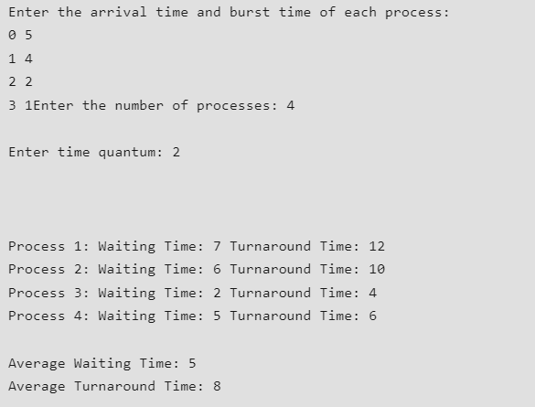

Priority Based Algorithm:
Priority scheduling is a non-preemptive algorithm and one of the most common scheduling algorithms in batch systems. Each process is assigned first arrival time (less arrival time process first) if two processes have same arrival time, then compare to priorities (highest process first). Also, if two processes have same priority then compare to process number (less process number first). This process is repeated while all process get executed.

Implementation –
- First input the processes with their arrival time, burst time and priority.
- First process will schedule, which have the lowest arrival time, if two or more processes will have lowest arrival time, then whoever has higher priority will schedule first.
- Now further processes will be schedule according to the arrival time and priority of the process. (Here we are assuming that lower the priority number having higher priority). If two process priority are same then sort according

to process number. Note: In the question, They will clearly mention, which number will have higher priority and which number will have lower priority.
- Once all the processes have been arrived, we can schedule them based on their priority.
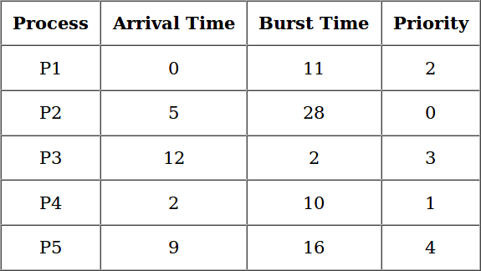

Gantt Chart –
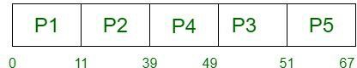

C# Programming Code:
using System;

class Program
{
static int totalprocess = 5;
static int[][] proc = new int[totalprocess][];
static int[] arrivaltime = new int[] {1, 2, 3, 4, 5};
static int[] bursttime = new int[] {3, 5, 1, 7, 4};
static int[] priority = new int[] {3, 4, 1, 7, 8};

// Driver code
static void Main(string[] args)
{
for (int i = 0; i < totalprocess; i++)
{
proc[i] = new int[4]; proc[i][0] = arrivaltime[i]; proc[i][1] = bursttime[i]; proc[i][2] = priority[i];
proc[i][3] = i + 1;
}

Array.Sort(proc, (x, y) => x[2].CompareTo(y[2]));
Array.Sort(proc, (x, y) => x[0].CompareTo(y[0])); Findgc();
}

// Using FCFS Algorithm to find Waiting time
static void GetWtTime(int[] wt)
{

// declaring service array that stores
// cumulative burst time
int[] service = new int[totalprocess];

// Initialising initial elements
// of the arrays
service[0] = 0;
wt[0] = 0;

for (int i = 1; i < totalprocess; i++)
{
service[i] = proc[i - 1][1] + service[i - 1]; wt[i] = service[i] - proc[i][0] + 1;

// If waiting time is negative,
// change it o zero
if (wt[i] < 0)
{
wt[i] = 0;
}
}
}

// Filling turnaroundtime array
static void GetTatTime(int[] tat, int[] wt)
{
for (int i = 0; i < totalprocess; i++)

{
tat[i] = proc[i][1] + wt[i];
}
}

static void Findgc()
{

// Declare waiting time and
// turnaround time array
int[] wt = new int[totalprocess]; int[] tat = new int[totalprocess]; int wavg = 0;
int tavg = 0;

// Function call to find waiting time array
GetWtTime(wt);

// Function call to find turnaround time
GetTatTime(tat, wt);
int[] stime = new int[totalprocess]; int[] ctime = new int[totalprocess]; stime[0] = 1;
ctime[0] = stime[0] + tat[0];

Console.WriteLine("Process_no\tStart_time\tComplete_time\tTurn_Around_Time\tWai ting_Time");

// calculating starting and ending time
for (int i = 0; i < totalprocess; i++)
{
wavg += wt[i]; tavg += tat[i];
Console.WriteLine(proc[i][3] + "\t\t" + stime[i] + "\t\t" + ctime[i] + "\t\t" + tat[i] + "\t\t\t" + wt[i]);

// display the process details
if (i != totalprocess - 1)
{
stime[i + 1] = ctime[i];
ctime[i + 1] = stime[i + 1] + tat[i + 1] - wt[i + 1];
}
}

// display the average waiting time
// and average turn around time

Console.WriteLine("Average waiting time is: " + (double)wavg / totalprocess);
Console.WriteLine("Average turnaround time is: " + (double)tavg / totalprocess);
}
}

OUTPUT:
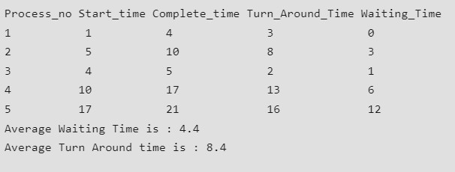
Lab tasks:
- Perform the above code with 8 Number of processes by randomly setting the arrival time and burst time and priority.
  - Use Round Robin Algorithm
  - Use Priority Based Algorithm
- Perform the above code with 10 Number of processes by randomly setting the arrival time and burst time and priority.
  - Use Round Robin Algorithm
  - Use Priority Based Algorithm

